|  |
| --- |
| **CME 2203 Lab 6 Pre-lab**  **Due Date:** 11.12.2023, 13:00  **Name:**  **Student Number:**  **Subject:** Op-Amp |

☞ Please read this document from start to finish carefully before starting your work.

☞ Prepare as a report (in **PDF)** including screenshots, simulation graphs, error logs etc. showing both increasing voltage source and output voltages.

☞ Prelab report must be prepared INDIVIDUALLY.

☞ Bring ALL your equipment, including your LM741 Op-Amp IC and multimeter!

Draw the following circuit on LTSpice Schematics and save to a folder of your choice. Note that the report we want will include more than just the circuit (graphs, netlist etc.)

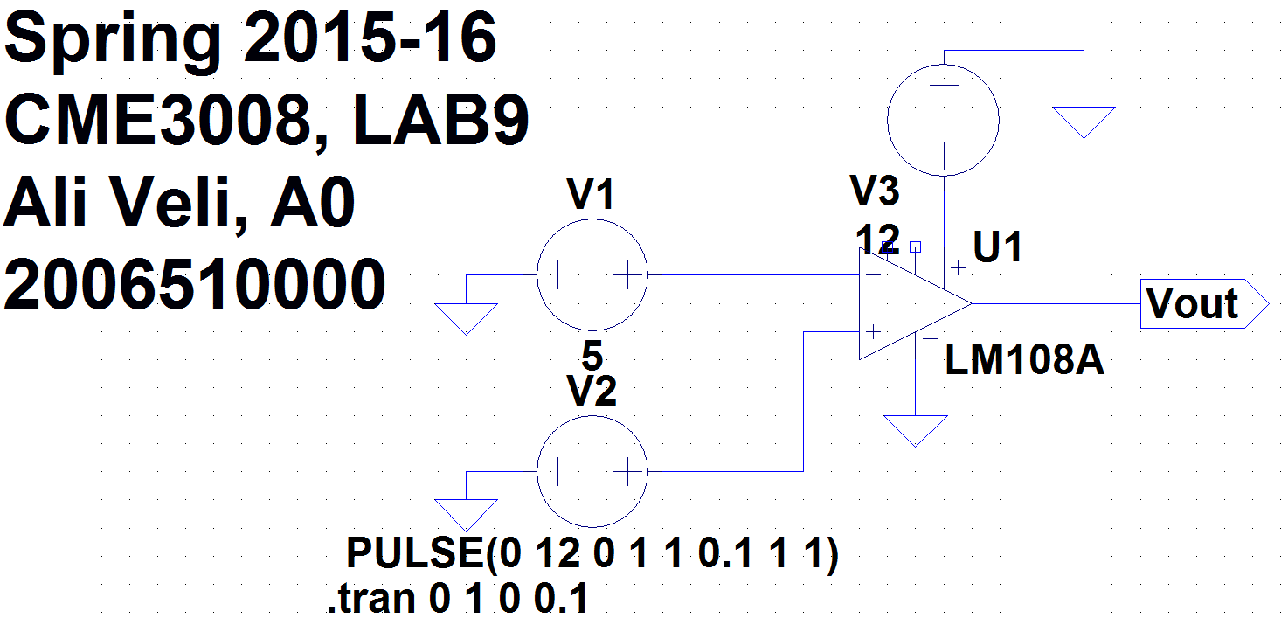

**Note**: If you want, you can change V3 to 9V and V1 to 6V in case you want to get the same results with lab experiment

1. For each screenshots in the report, top of the window should contain the graph plot panes, and the bottom of the window should contain:
   1. The circuit diagram
   2. The text label
   3. The Spice Error Log(see instructions below on showing the error log)
2. We adjust the V2 so it simulates a voltage source increasing from 0V to 12V in a linear fashion:

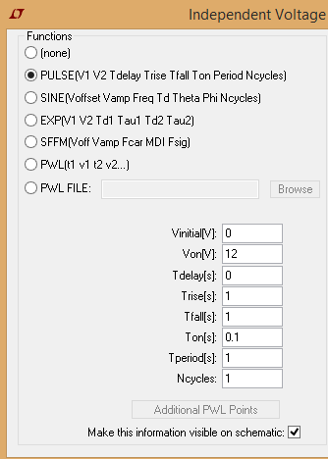

1. Set V1 to +5V DC. It will serve as our reference voltage.
2. Add the op-amp LM108A, it’s in the Opamps folder in components. Note that in the lab we will use a different Op-Amp, the LM741, but they are similar enough for our simulation purposes.

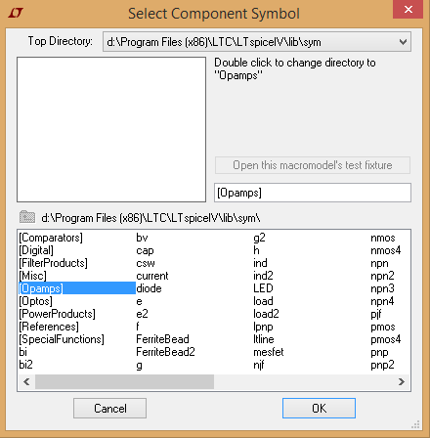

1. You can insert the *output net label* by clicking on the net label icon and defining it as an output port, naming it “Vout”.

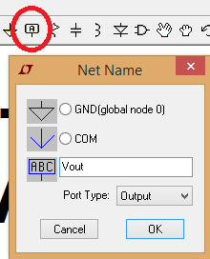

1. Now, we are ready to run the simulation! Click on the running man  and edit the simulation command (Remember, you can also change this command later by going to Simulate\Edit Simulation Command):
   1. Under the Transient tab, select the following parameters:
      1. Stop Time : 1
      2. Time to Start Saving Data : 0
      3. Maximum Timestep : 0.1 and click OK.

Click the running man again. You should see an empty graph on top of the window now. Let’s fill it with graphs!

* 1. Click the red probe appearing on the circuit to the wire connecting to positive side of V2. It should show linearly increasing voltage. Right click on V(n003) and change default color to red. This is our Analog input. Don’t add a new pane, we want to see the two graphs together.
  2. Click the red probe appearing on the circuit to the output port “Vout”. Right click on V(vout) and change default color to blue. This is our digital output.
  3. Observe that the output jumps from about 0.1V to about 11.5V where the analog input voltage is 5V.
  4. Finally, we want to view the Spice Netlist that defines our circuits and simulation commands on the right side of the circuit. Over the background of the circuit, right click, go to View\SPICE Netlist and carry this window to the right side of the circuit. It should be visible on your screenshot. It should NOT block the graphs or the circuit.

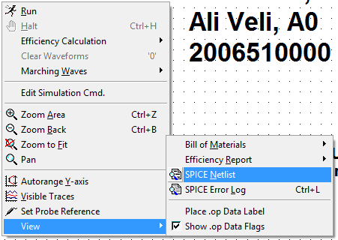

May be you are not aware of it, but you have just built a 1-bit ADC(Analog to Digital Converter). Input values 0-5V correspond to a logic output of 0(not necessarily 0V, but a very low value), and values greater than 5V correspond to logic 1(Little less than 12V). We have represented a range of 12V with only two logic values.

|  |  |
| --- | --- |
| **Vin** | **Vout(Logical)** |
| 0-5V | 0 |
| >5V | 1 |

Congratulations! You are all set! Now have some rest.

Also, please try to understand how these circuits work.